Paleta de cores site de autória web: Carros-Classicos
Tons de vermelho que serão usados:
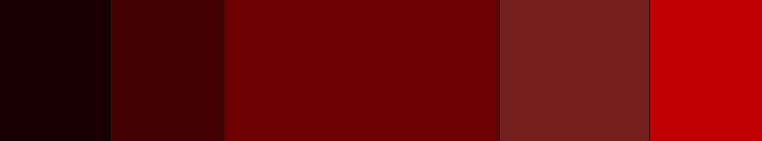
RGB: 39–0–0 RGB: 62–0–0 RGB: 107–0–0 RGB: 139–0–0 RGB: 165–0–0
Tons de cinza que serão usados:

RGB: 133–132–132 RGB: 88–88–88 RGB: 36–36–36 RGB: 0–0–0 RGB: 1–1–1

